Rieter Introduces C 70 High-performance Card
Switzerland-based Rieter Machine Works Ltd. reports its C 70 1.5-meter-wide card offers a number of improvements over the earlier-generation C 60 card.
According to the company, a redistribution of the carding zones in the flats area and redesigned flats guiding enables the new card to increase production performance by up to 40 percent while maintaining or even improving sliver quality. The C 70 card features 32 operative flats, providing a 45-percent-greater active flats area than the C 60, and a 60-percent-greater area than conventional cards. Thanks to the new card's precise flats guiding system and updated design, a precise and reproducible minimum distance of 0.1 millimeters can be set between the cylinder clothing and the flats. The company also has reorganized the flats cleaning function.
Other C 70 features include: an extraction knife with variable ejector distance located in the pre- and post-carding area to optimize fiber utilization, plus quick exchange of the knife without tools; a frequency converter that enables infinitely adjustable flats speed independent of the cylinder speed; and 15-percent lower energy needs per kilogram of produced card sliver than the C 60. Options include Rieter's exclusive fully automatic integrated cylinder grinding system.
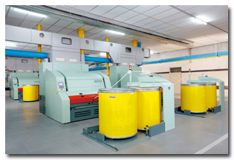
Rieter's 1.5-meter-wide C 70 card
May 24, 2011

